# **Delegation Event Model**

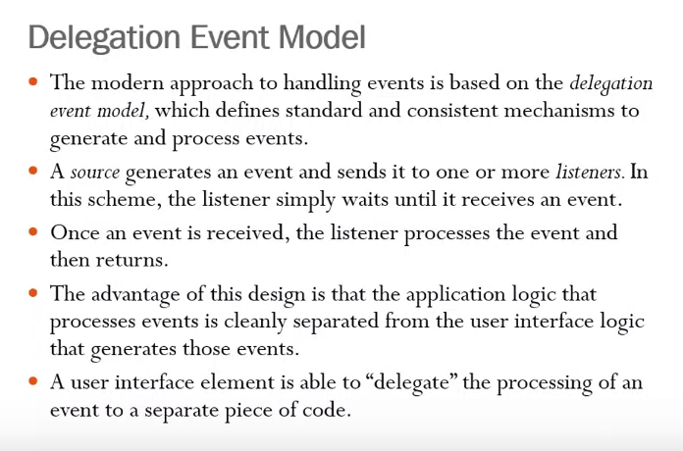

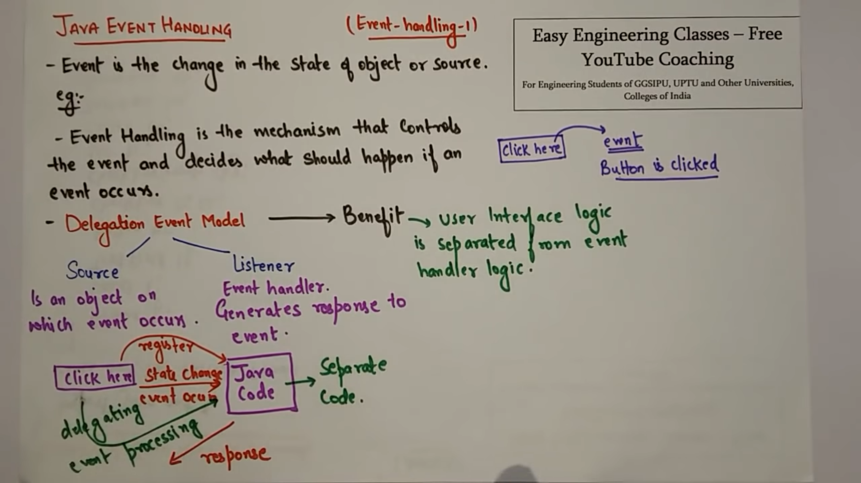

1. There can be one listener.
2. There can be a receiver who receives and sends it to another listener.

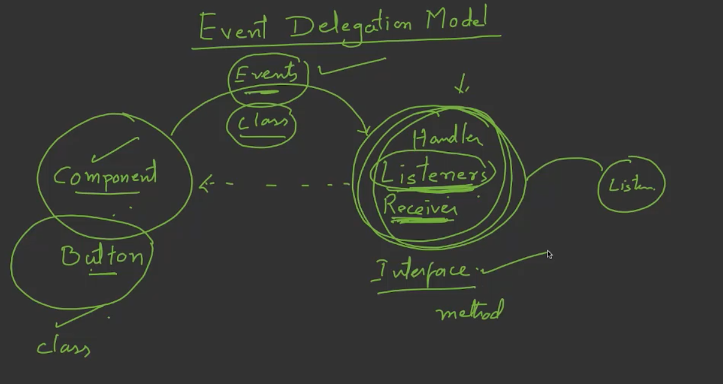

Classes are built in-available for components.  
Classes are built in-available for events.  
Listener will be our own user_defined class which implements some interface.

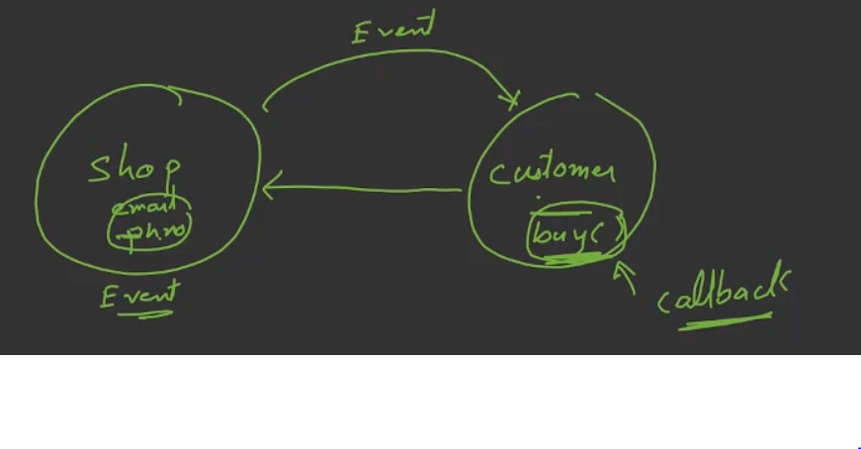

You have given your mobile number and email_id to the shop.  
After some-times the shop announces the offer and sent to the customer via sms,email. (event is generated).   
These offers can be claimed by the customer (event-handling)

**Outline of even classes and listener interface**

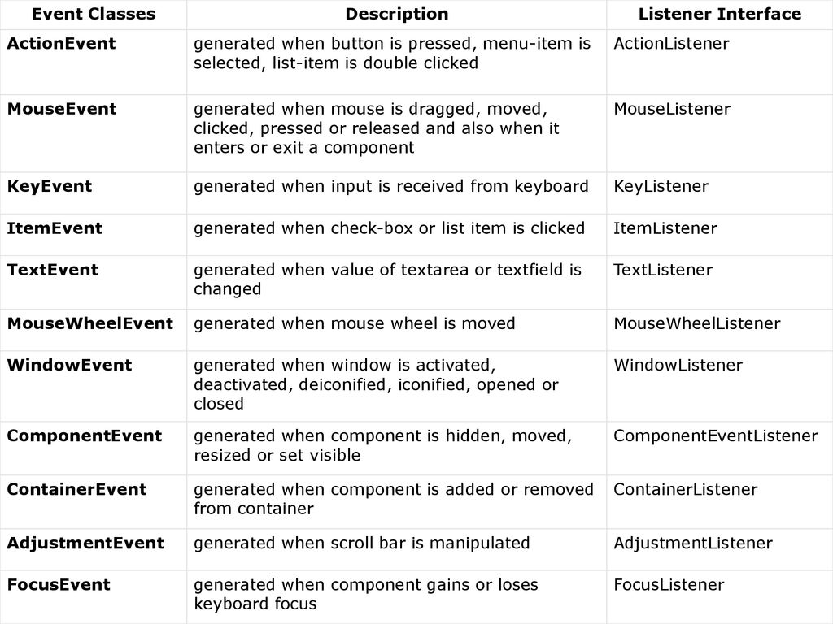

# **Event**

Event Source 🡪 an object that generates an event. When-ever an event is generated, source must provide the occurred event info to the listener by registering the control with the corresponding listener.

Object.addTypeListener(this);  
public void addTypeListener (TypeListener this) { }

Event Listener 🡪

Implementing the ActionListener interface  
public void actionPerformance (ActionEvent ac) { }

Event classes 🡪

# **Event Sources**

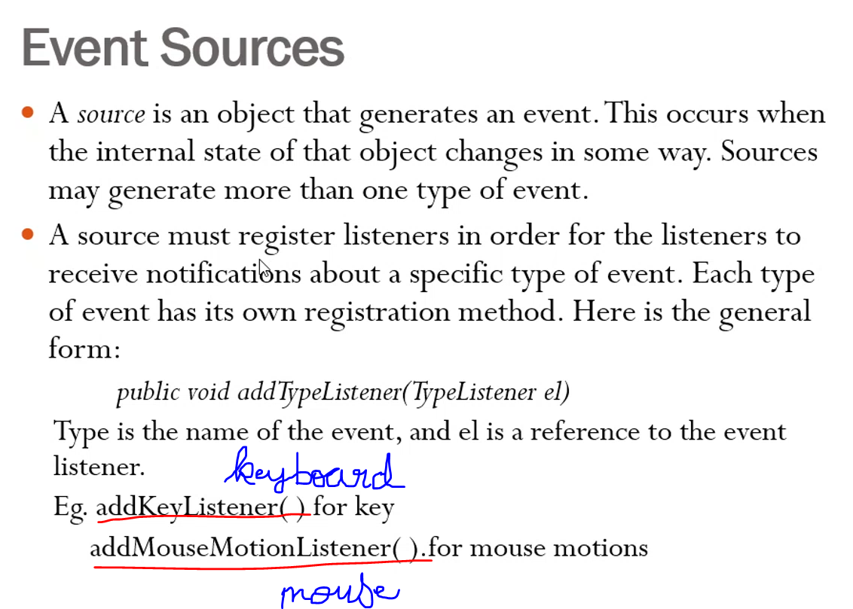

A mouse is an object that generates an event. Mouse can generate events like scroll, click, double click etc..

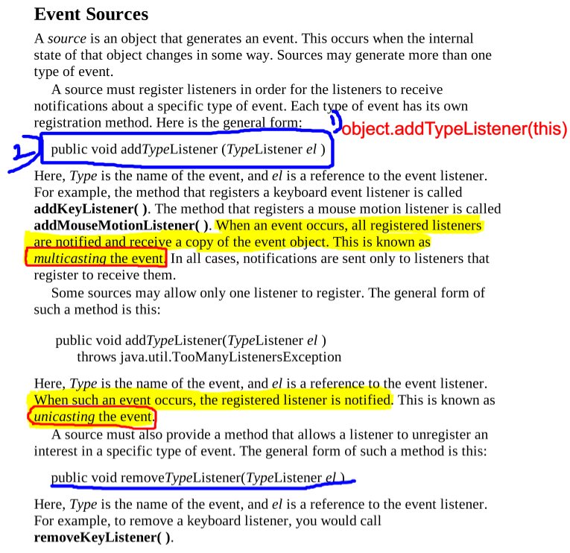  
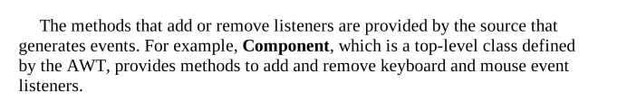

# **Event Listeners**

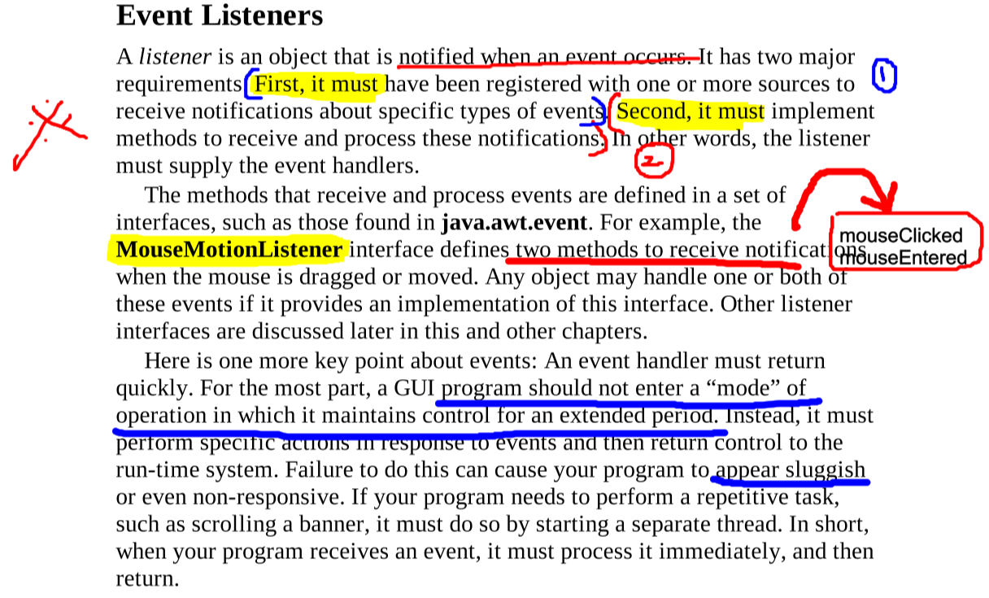

# **Event Classes**

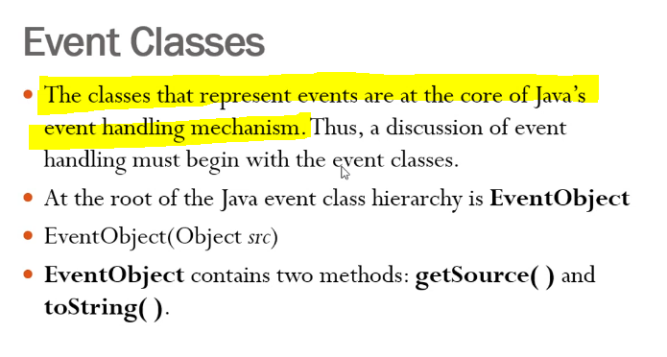

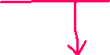

Returns the string equivalent of an event Returns the source of the event

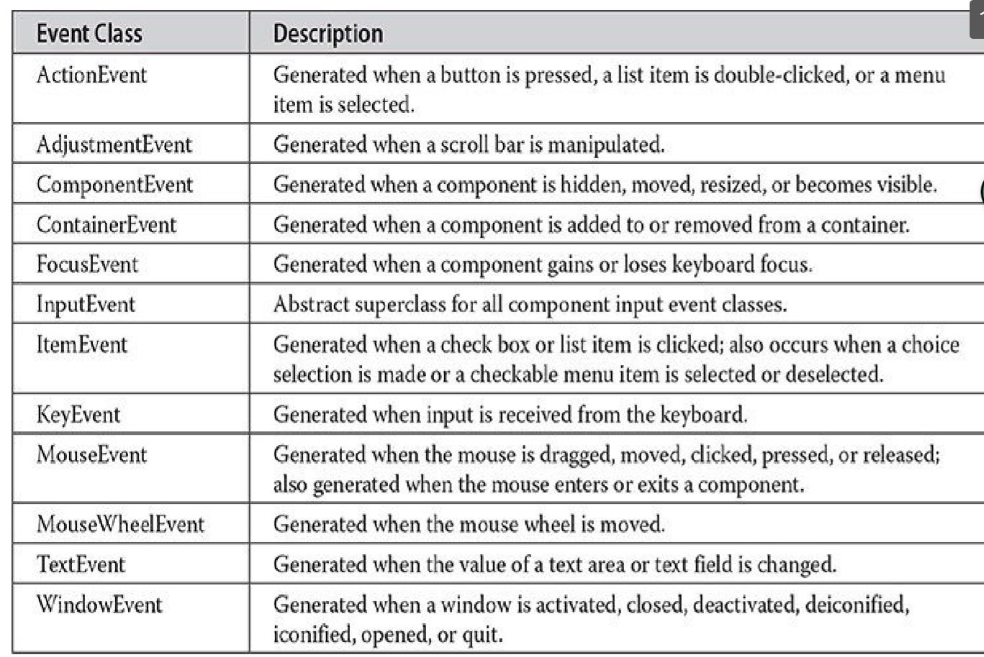

## ActionEvent Class (button press)

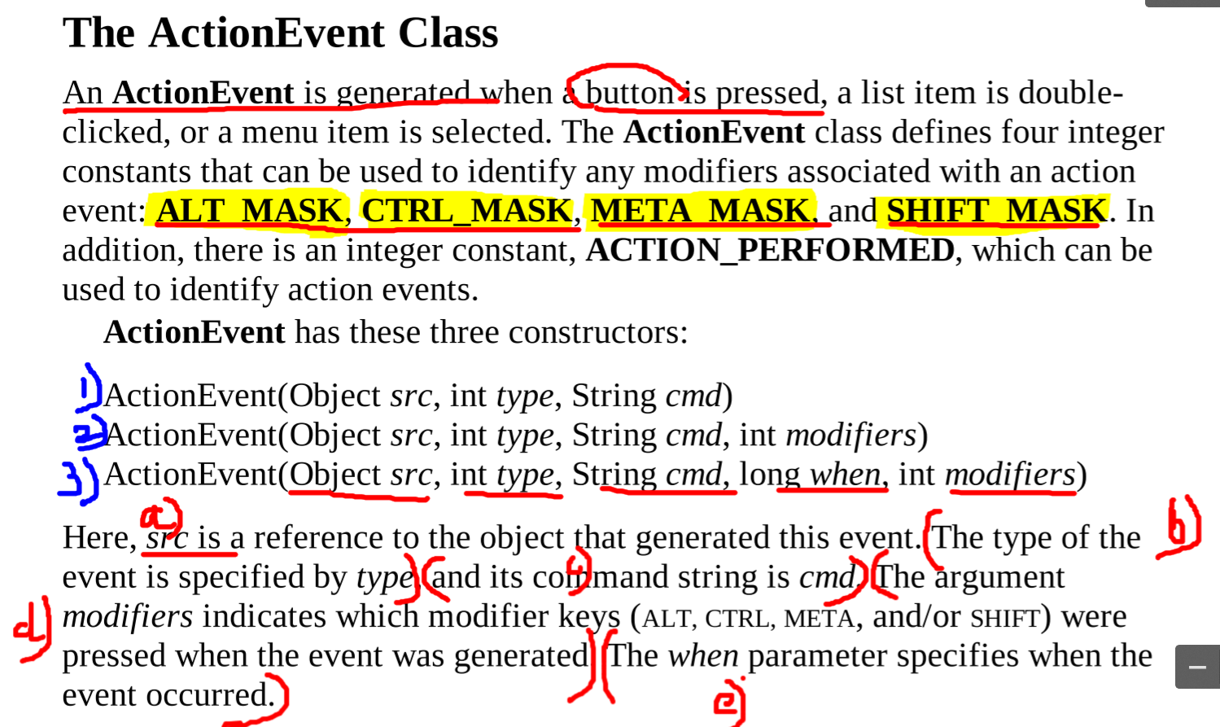

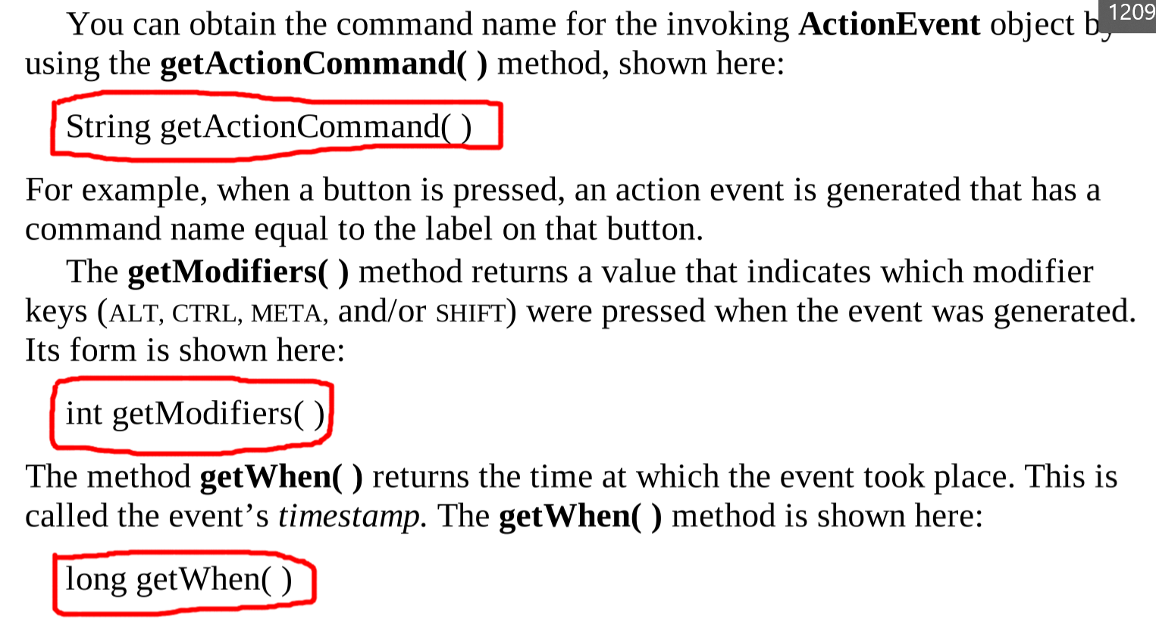

## Adjustment Event Class (scroll bar)

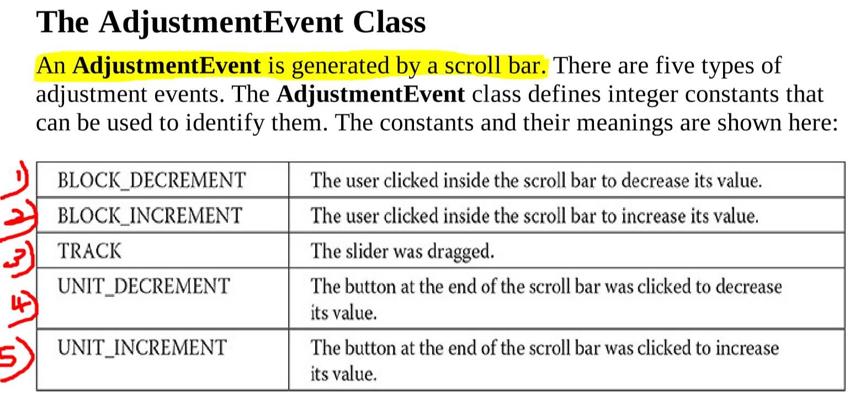  
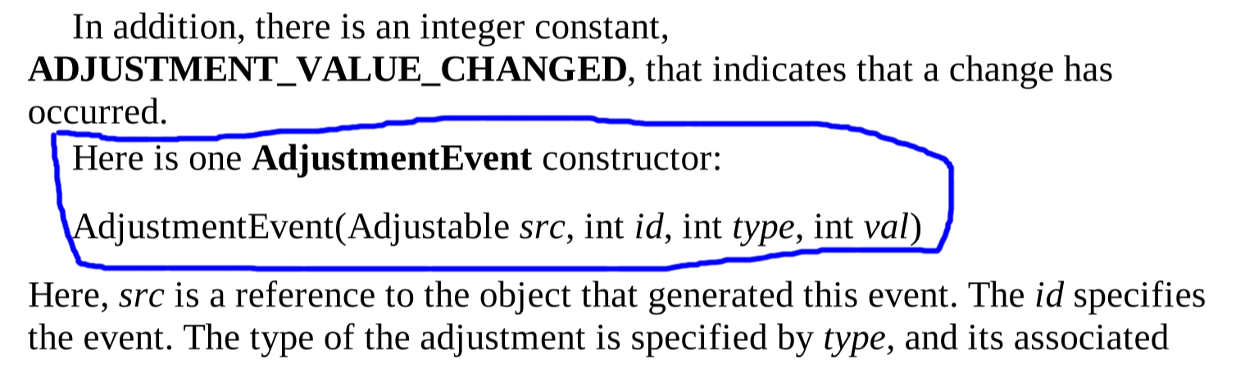

## Component Event Class (size, position, visibility of a component changed)

The component may be a label, textbox, combo-box, picture   
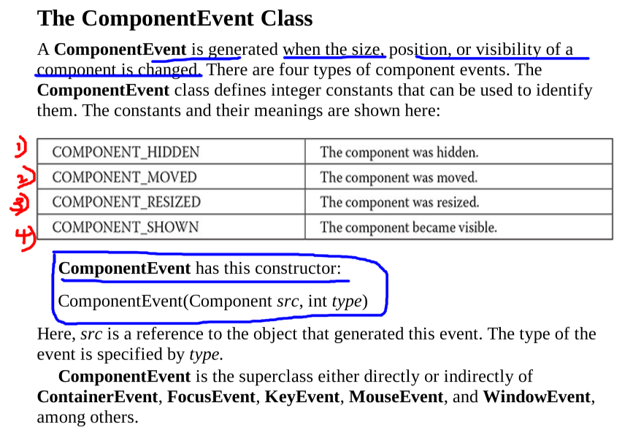  
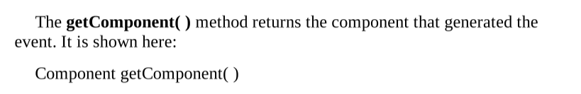

## Container Event Class

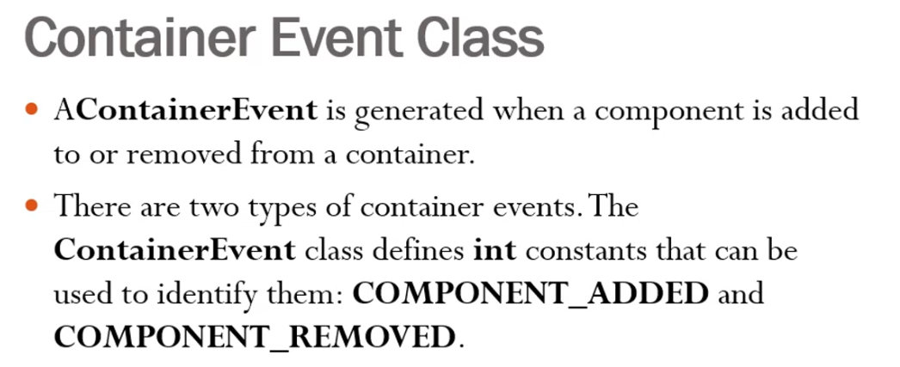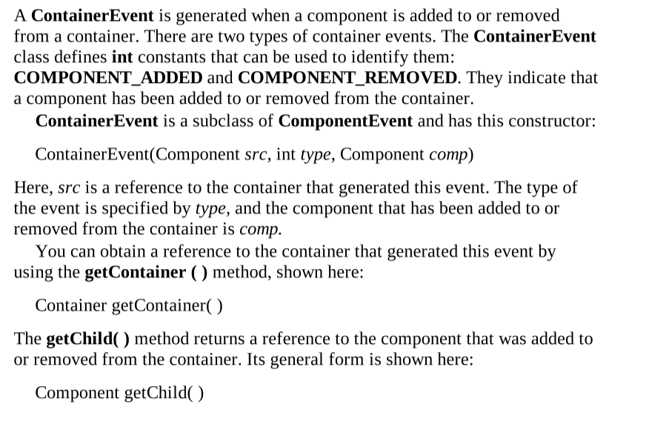

## **Focus Event Class**

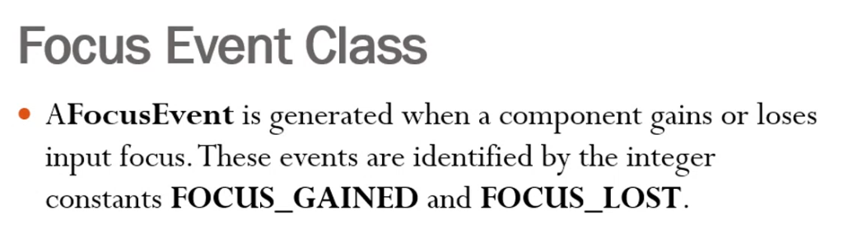

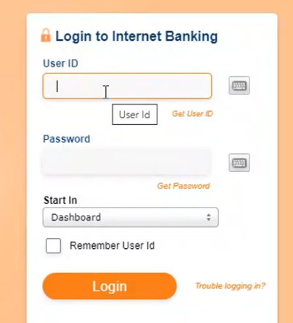 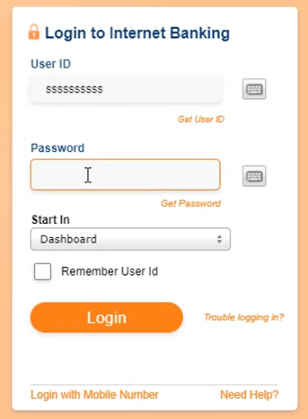

User-id is focussed and User-id is not focussed and  
Password is not focussed Password is focussed

# Key Event Class

## **Mouse Event Class**

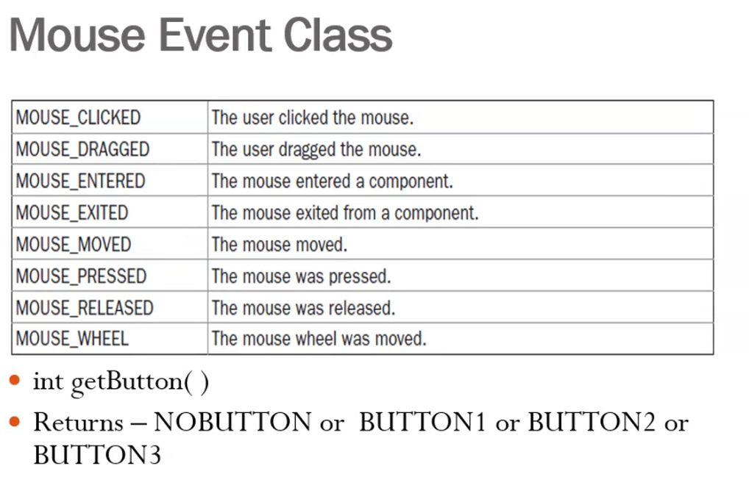

## **Mouse wheel Event Class**

## **TextEvent Class**

## **Window Event Class**

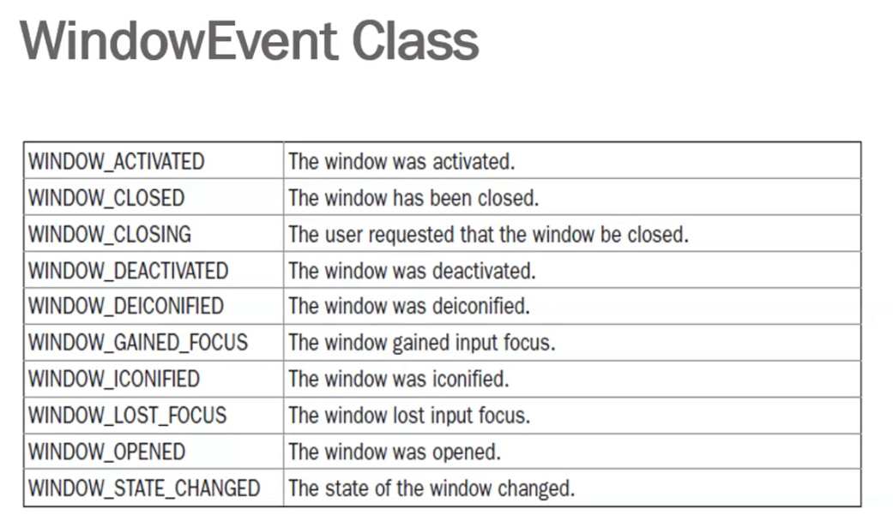

# **Source of Events**

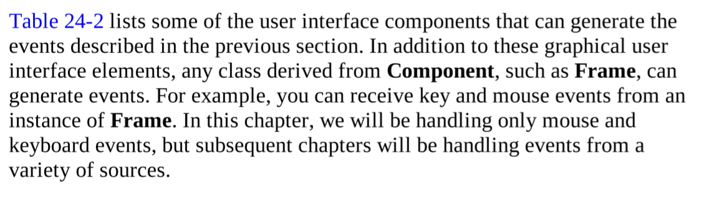  
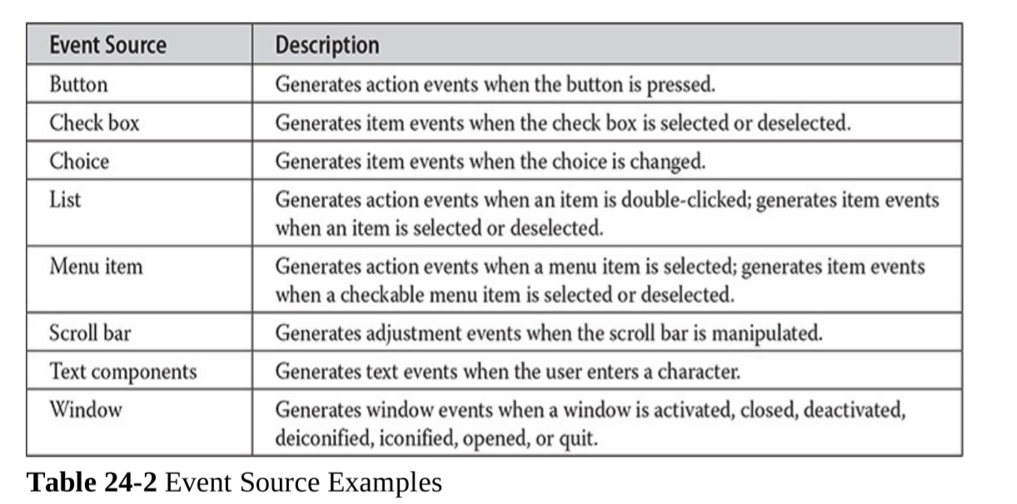

The above events are generated and these must be handled by the listeners

# **Event Listener Interface**

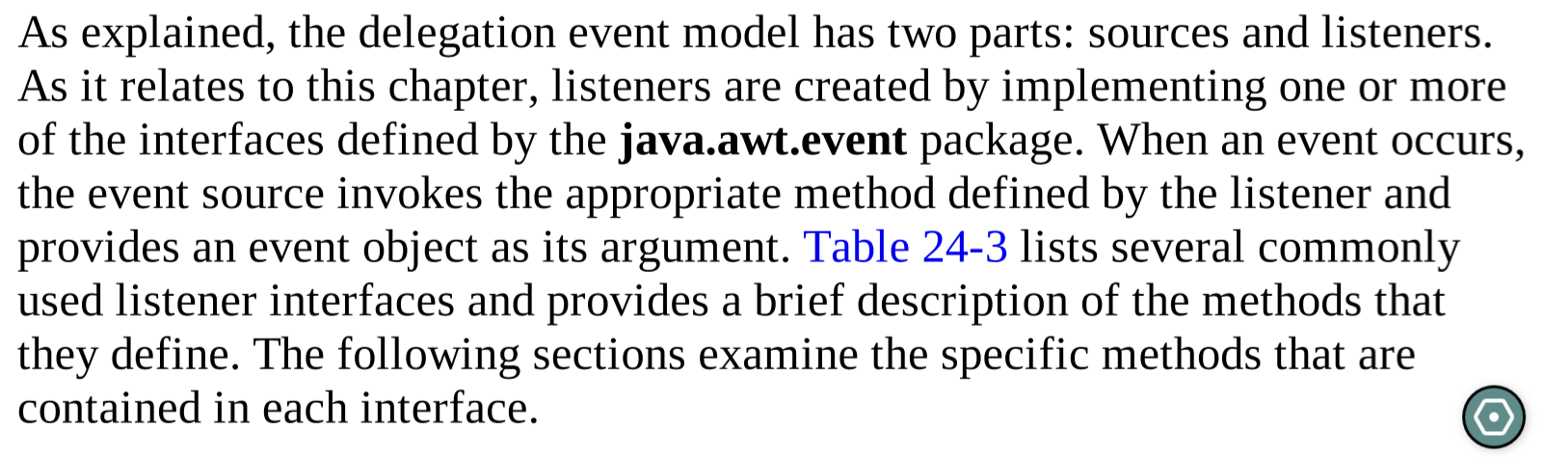

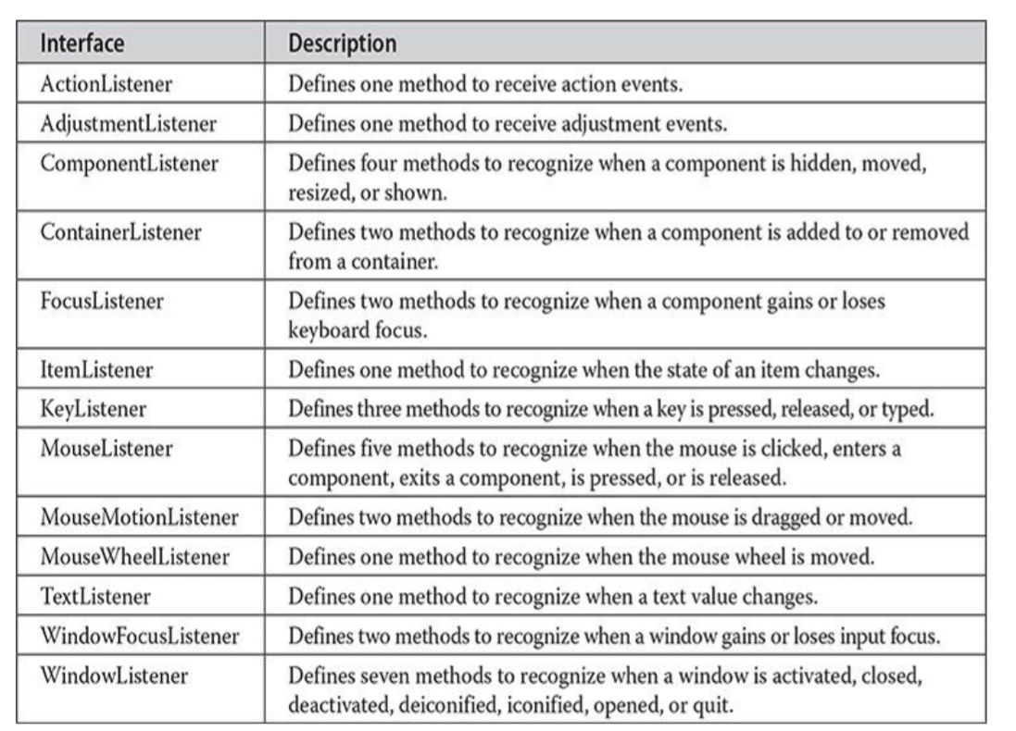

## **ActionListener Interface**

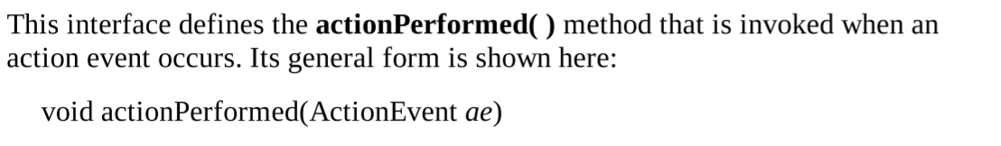

## **Adjustment Listener Interface**

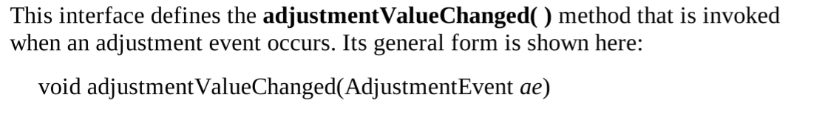

## **Component Listener interface**

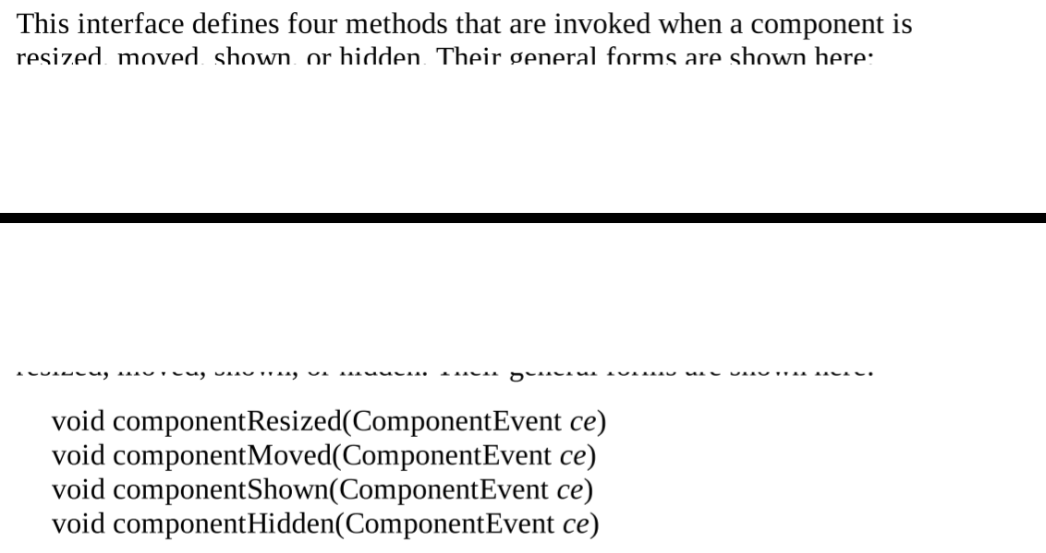

## **Container Listener interface**

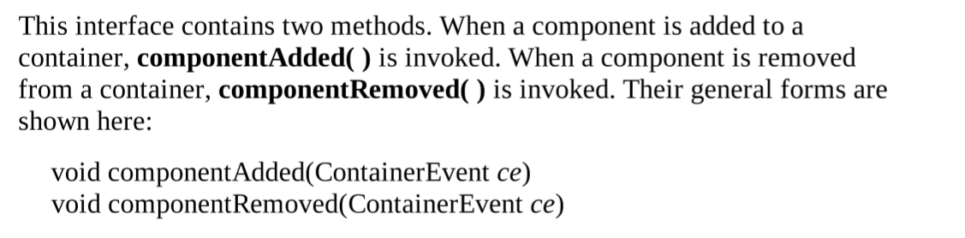

## **Focus Listener interface**

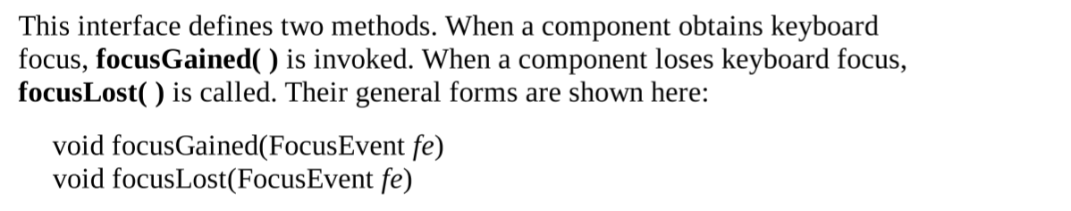

# Key Listener Class

## **Key Listener interface**

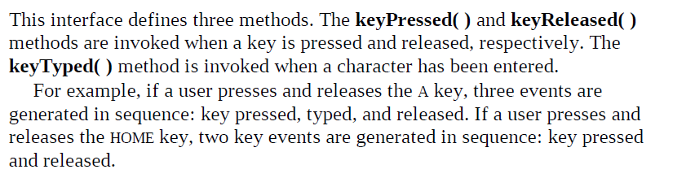  
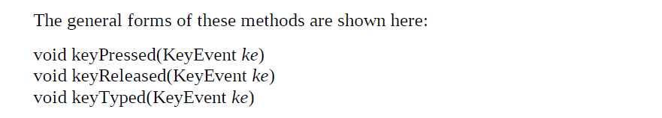

## **Mouse Listener interface**

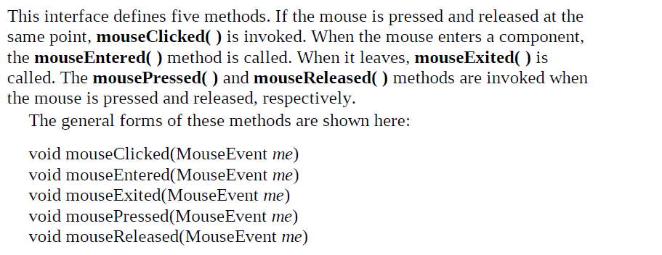

## **Mouse Motion Listener interface**

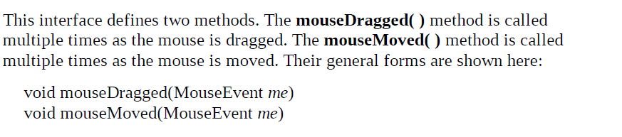

## **Mouse Wheel Listener interface**

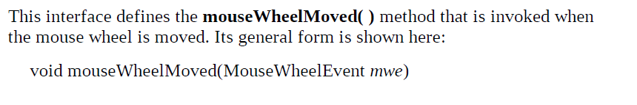

## **Window Focus Listener interface**

## **Window Listener interface**

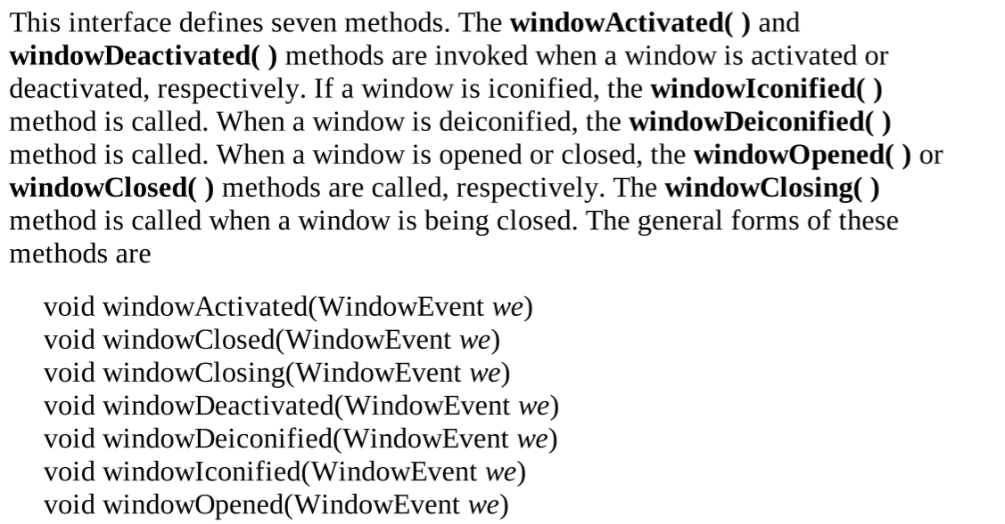

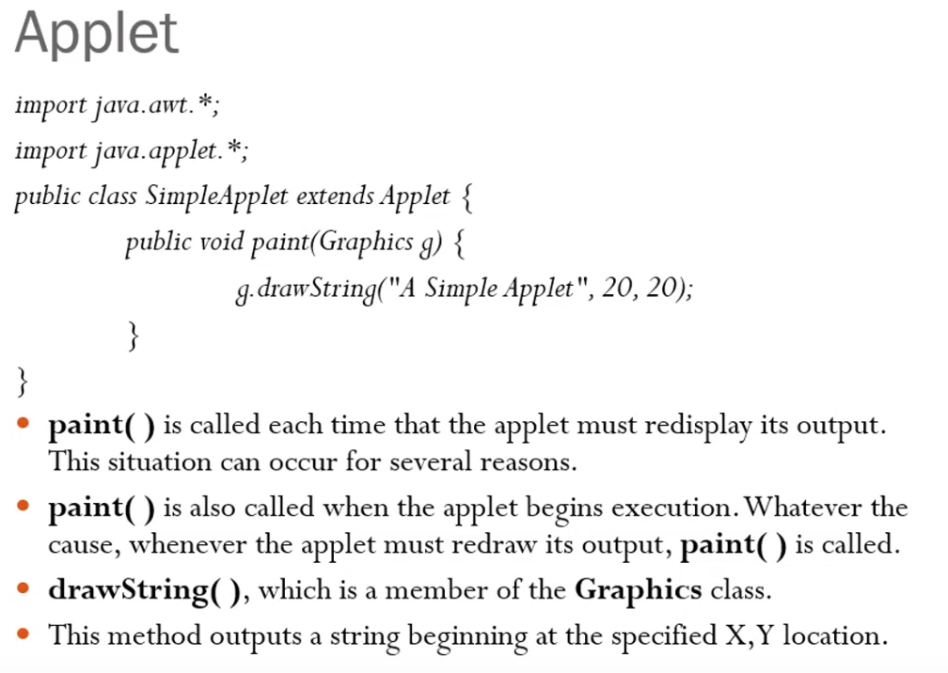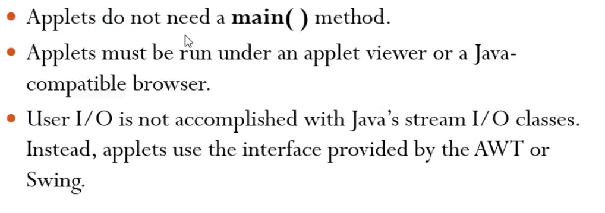

**Painting is the process of changing the window**

**java-applet is running at the back-end completely. Unless the applet window is closed, it runs.**

# **Example-Refer button_ActionListner.java**

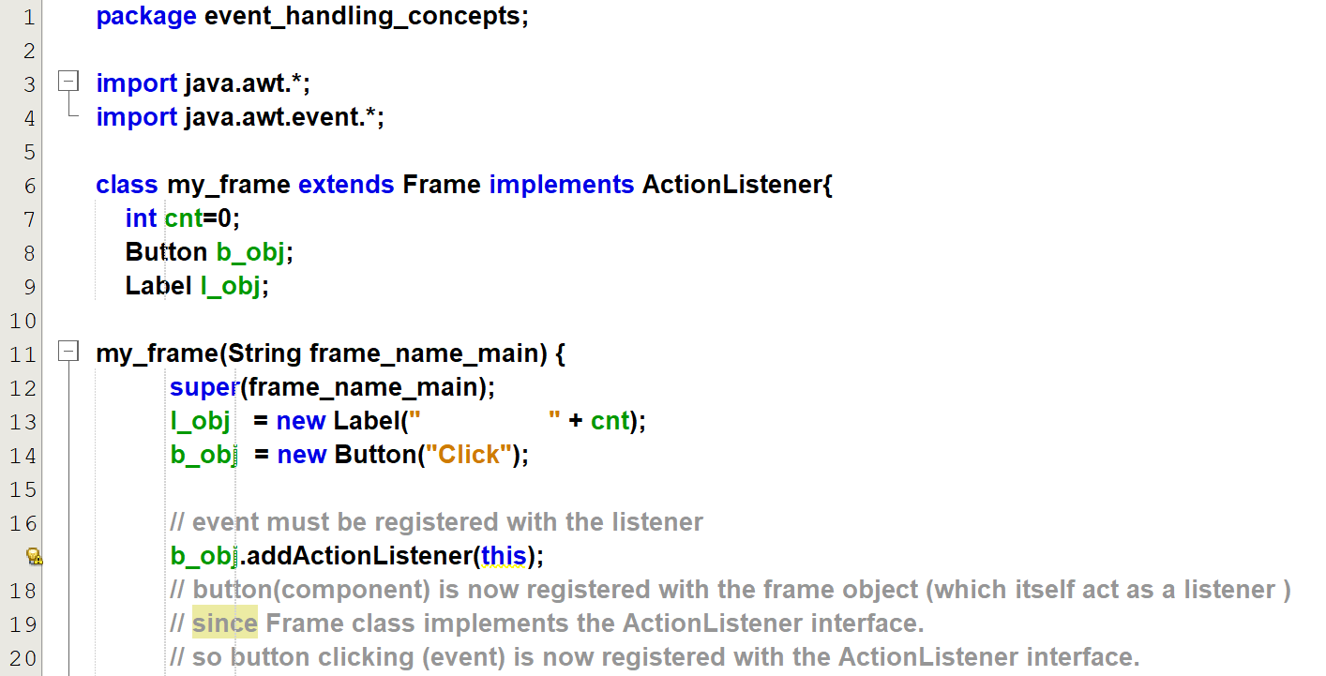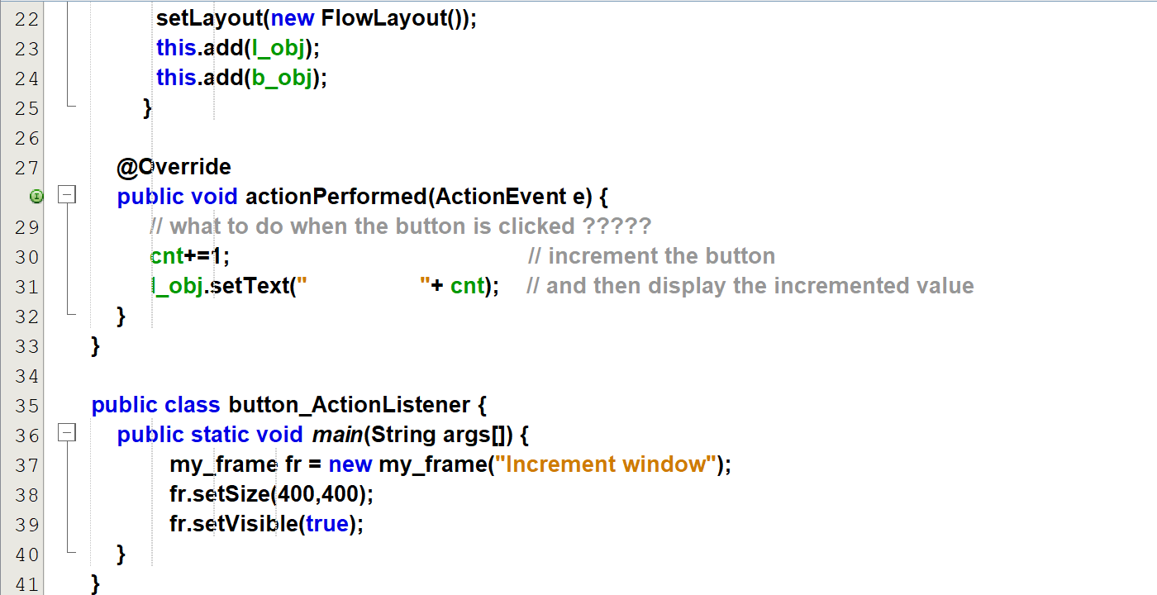

**ActionListener 🡪 public void actionPerformed(ActionEvent e)**

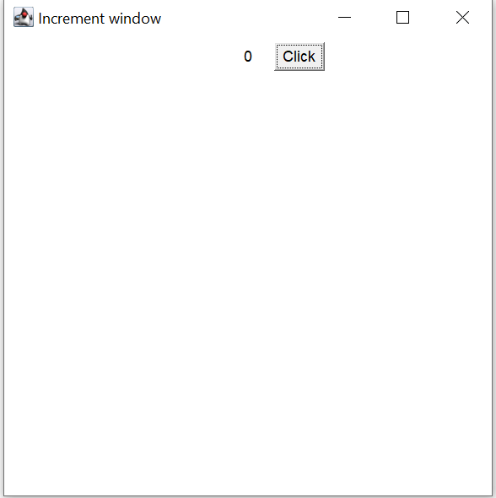

After clicking 6 times

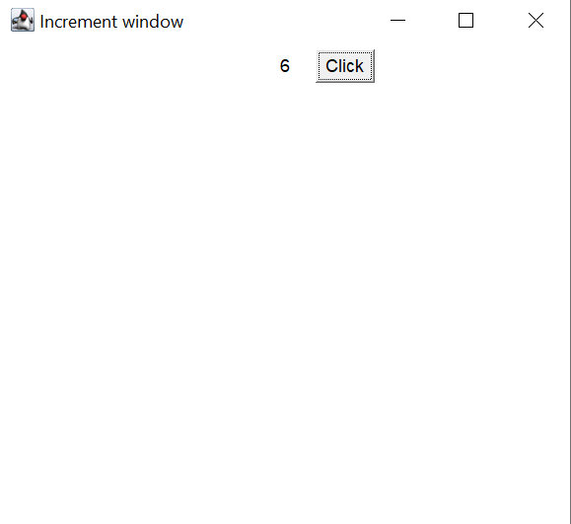

# **Example-Refer checkbox_ItemListener**

Output

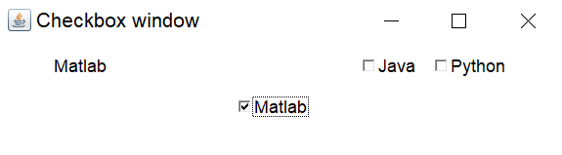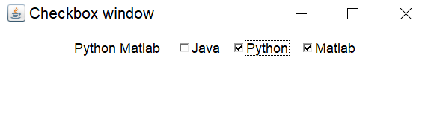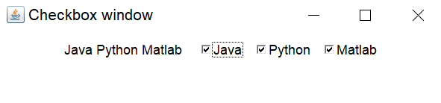

# **Example-Refer checkbox_ItemListener**

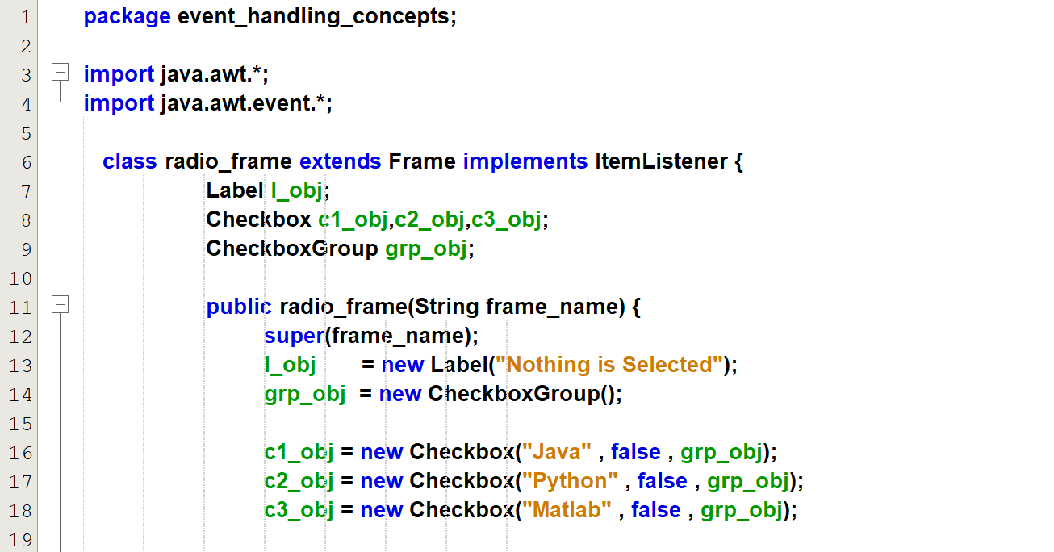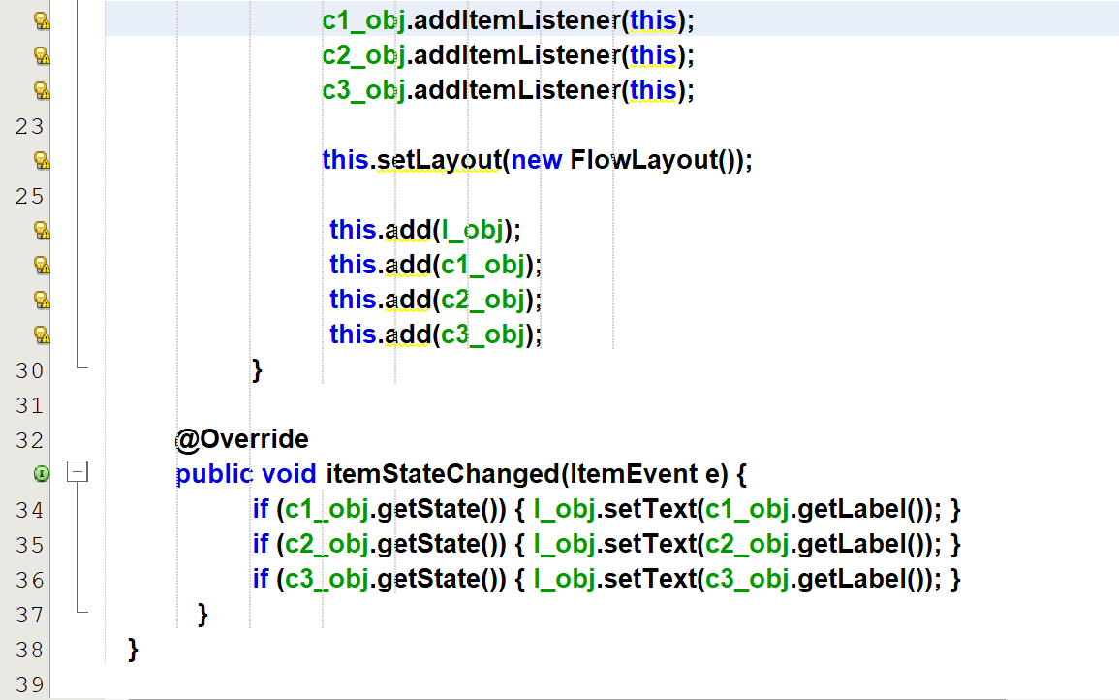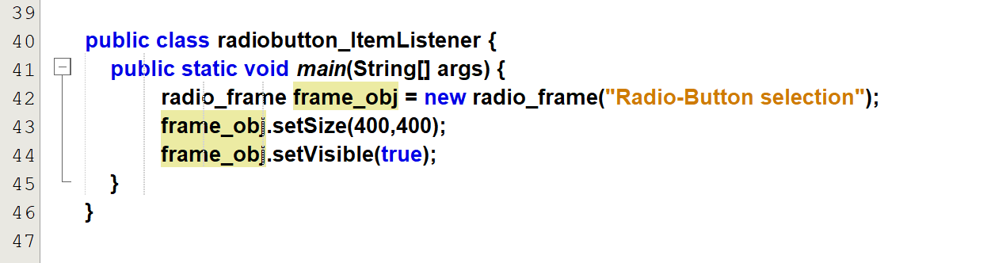

**Output:**

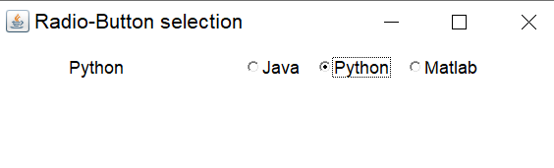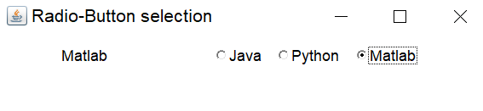

# **Example-Refer textfield_textevent**

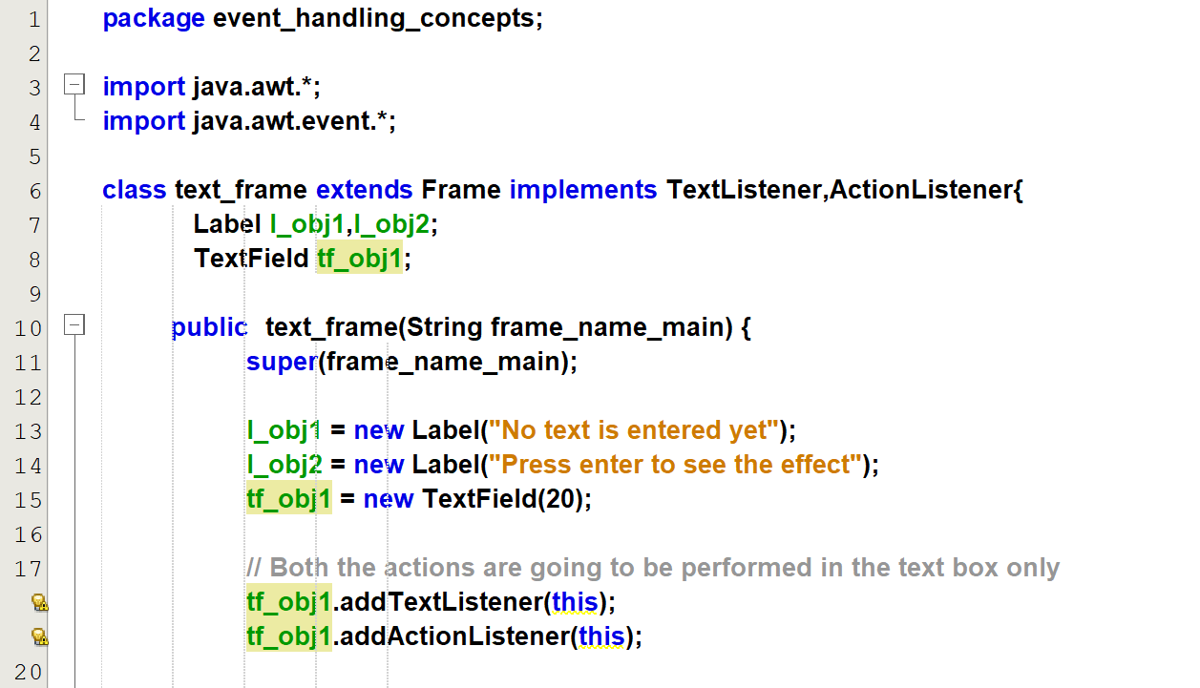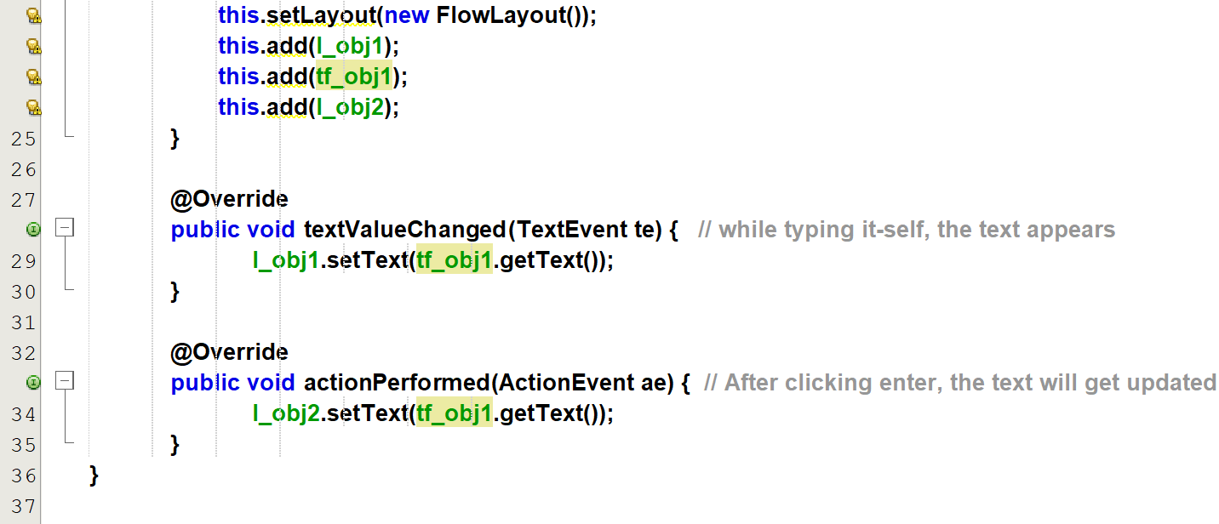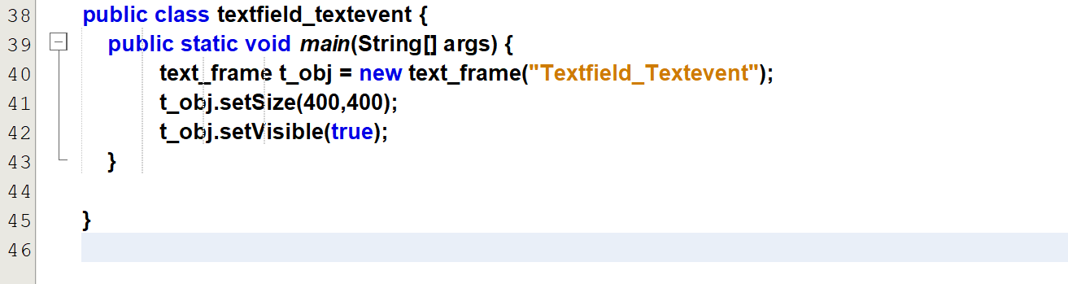

**Output:**

[**textfield_textevent_output**](Output%20clips/textfield_textevent_output.mkv)

From 18 to 26 we are getting this warning message, since we  
Once the constructor finishes, the object is ready for their task, but during the construction of the object it-self, we are trying to use that object (i.e involving the object in the event-handling).  
So we are using an incomplete object.

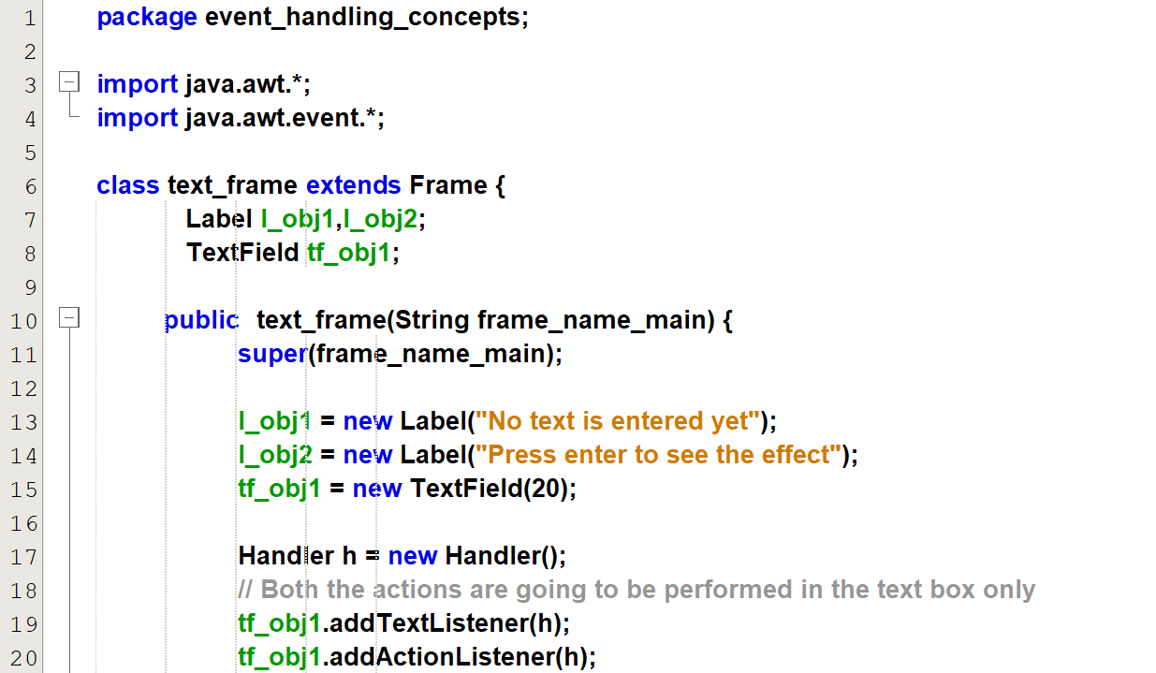  
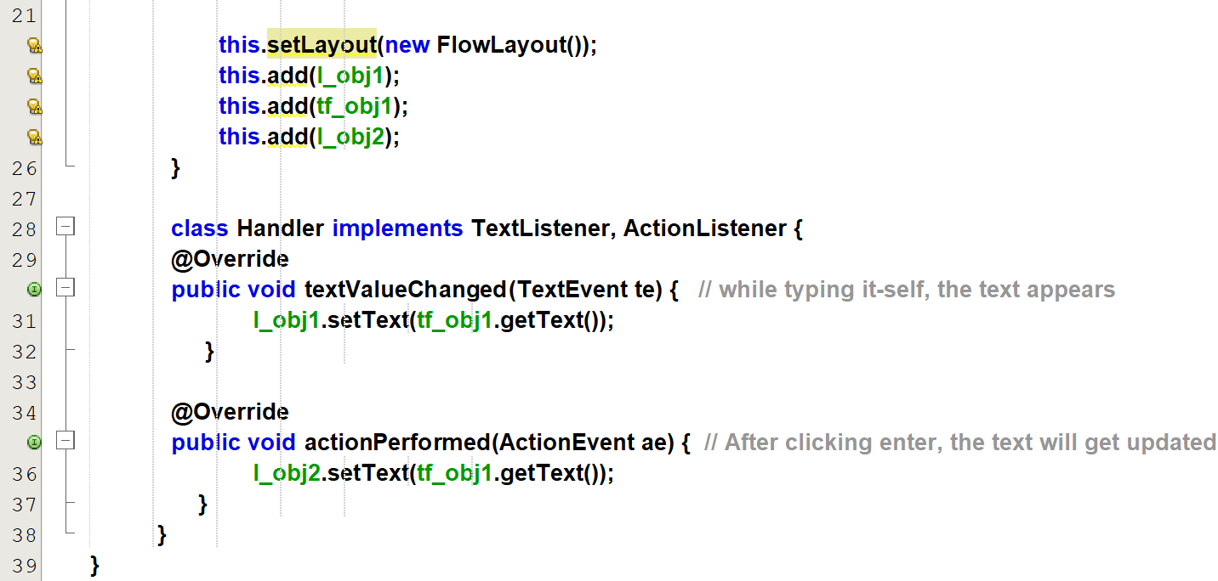  
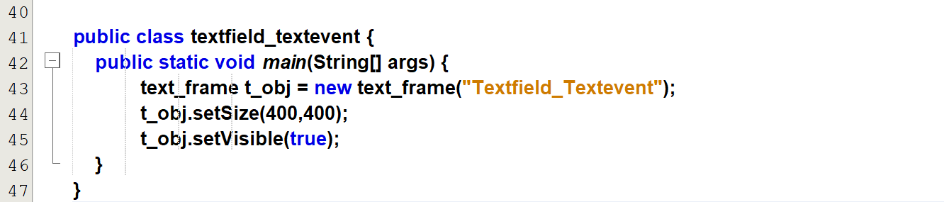

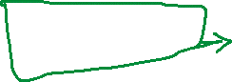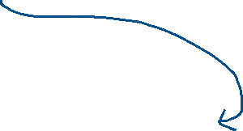

# **Example-Refer selecting_text**

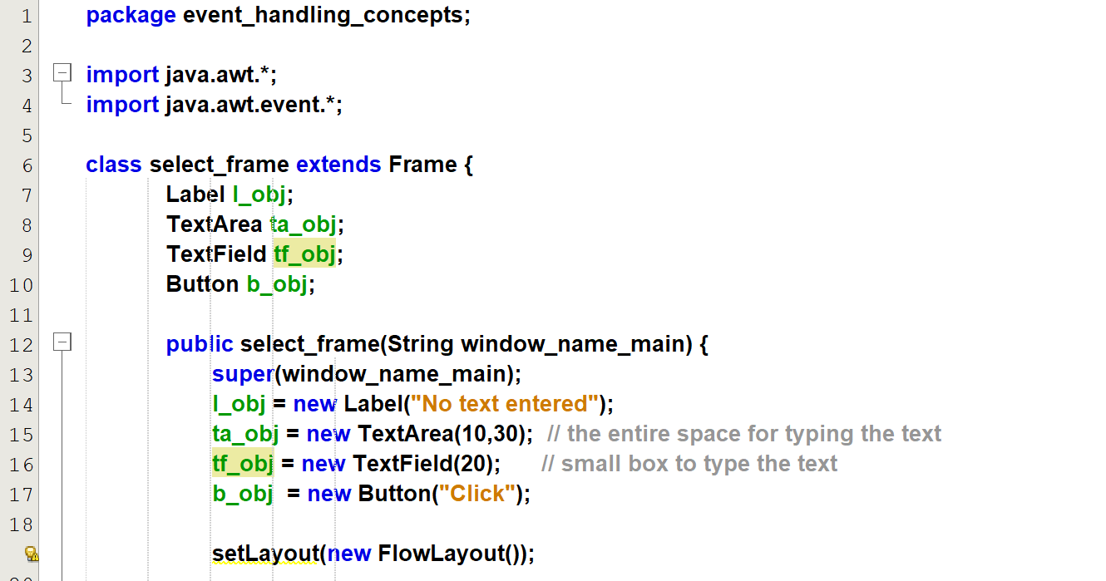  
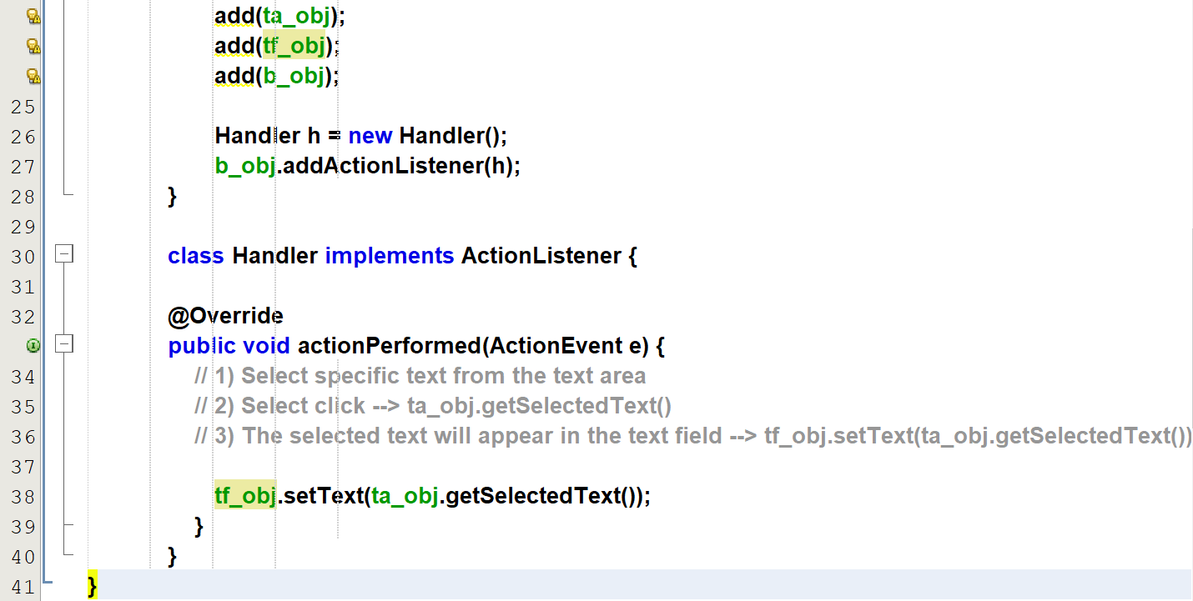  
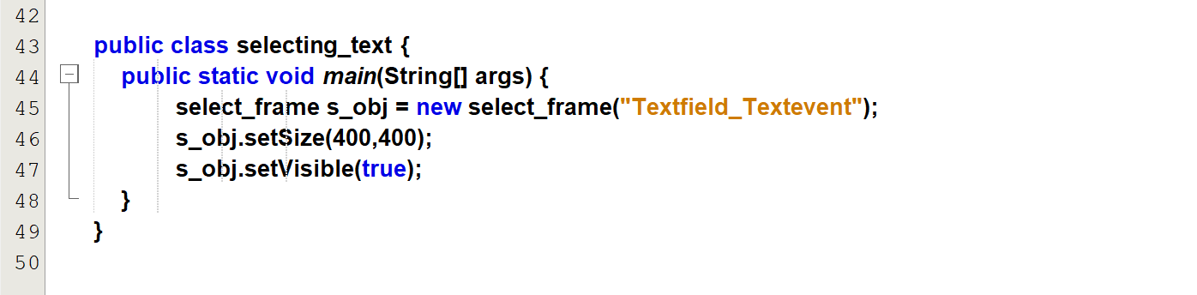

Output: [selecting_text_output](Output%20clips/selecting_text_output.mp4)

# **Example-Refer textfield_to_textarea.java**

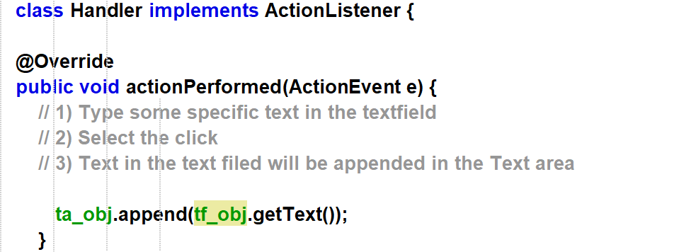

The above is the only change from the previous code.

Output: [textfiled_to_textarea](Output%20clips/textfield_to_textarea_output.mp4)